Lecture No.2 PARASITOLOGY DR.Raad H.H.
Helminthology
General Introduction
- Helminths (Greek word ) = Worms.
Term medically refers to any parasitic worm or worm – like organism that infects human ; which are large ,multicellular organism belong to (Subkingdom Metazoa) , generally adult stages seen by naked eye , and some are microscopic ,could be either free or parasitic living.
The disease called "Helminthiases"
- Classification of Helminthology :
Divided to 4 phyla
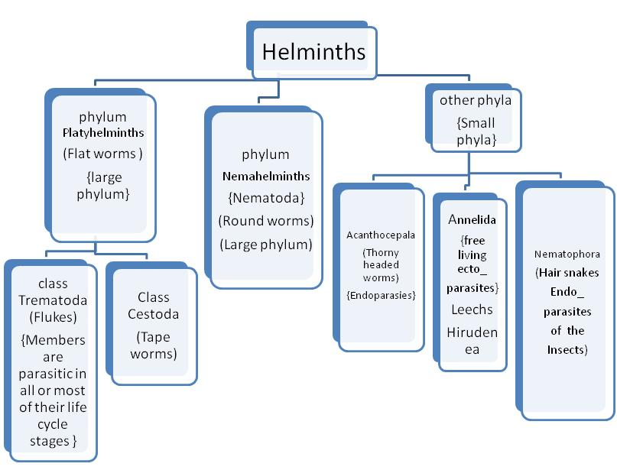

- The nematodes (roundworms) include the major intestinal worms (also known as soil-transmitted helminths) and the filarial worms that cause lymphatic filariasis (LF) and onchocerciasis, whereas the platyhelminths (flatworms) include the flukes (trematodes), such as the schistosomes, and the tapeworms (cestodes), such as the pork tapeworm that causes cysticercosis (Table 1).
- Based on EPGs and their association with morbidity, individuals are classified into categories of light, moderate, and heavy infection by the WHO . Furthermore, in the case of soil-transmitted helminths, the WHO recommends use of both prevalence and intensity of infection to classify communities into transmission categories — category I (high), category II (medium), and category III (low). These transmission categories are assigned according to both the number of heavily infected people in the community (greater or less than 10%) and the prevalence of infection (greater or less than 50%). For example, a community with greater than 50% prevalence but less than 10% heavy infection would be considered a category II transmission community.
- Age dependency: Much epidemiologic research has focused on heterogeneity in the intensity of helminth infection by age . Changes with age in the average intensity of infection tend to be convex, rising in childhood and declining in adulthood. For Ascaris lumbricoides and Trichuris trichiura, the heaviest and most frequent infections are in children aged 5–15 years, with a decline in intensity and frequency in adulthood . Similarly, for all the major schistosomes, the heaviest & most frequent infections are in older children aged 10–15 years . In contrast, hookworm frequently exhibits a steady rise in intensity of infection with age, peaking in adulthood . Similarly, the pathologic events that occur with filarial infections also predominate in adulthood.
- Some of the strongest evidence for protective immunity to human helminth infection has come from epidemiological observations of a “peak shift” in prevalence and intensity of infection with age . Briefly, if age-infection data are compared across host populations, the peak level of infection intensity (e.g., EPGs for intestinal helminths) is higher and occurs in younger individuals when transmission is also higher, but the peak intensity of infection is lower and occurs in older individuals when transmission is lower .
- For a number of species of parasitic worms, it has been established that the intensity of infection is a heritable phenotype . The most advanced research program investigating the identity of host genes that influence helminth infection involves schistosomiasis. The first genome scan for a helminth infection identified linkage of intensity of infection with S. mansoni in a Brazilian population to the chromosomal region 5 (q31–q33) , and subsequent confirmation of this link was established in a Senegalese population . The chromosome 5(q31–q33 )region includes loci for numerous immune response genes, including those encoding the Th2 cytokines IL-3, IL-4, IL-5, IL-9, and IL-13, interferon regulatory factor 1, colony-stimulating factor 2, colony-stimulating factor 1 receptor, and the IL-12/IL-23 p40 subunit .

- Factors limited helminthes infections:
- No. of parasites ( worm) ; i.e. size of parasitic infections (the "worm burden" or “intensity of infection”) which is commonly measured by the number of eggs per gram (EPGs) of feces for intestinal helminths and schistosomes , could be light ; or moderate or heavy .
- Host – parasite relationship.
- Immunity & host response (e.g. Esinophilia ; IgE production & hypersensitivity reaction ).
- Re – infection
- Effect of the mature parasites existing population on young forms entering the same host .
- Infection with one species of helminthes may increase host susceptibility to infected with other species .
- Helminths cannot Multiply in the host i.e. most Helminth infections are light since single egg lead to one worm unlike that what found in massive multiplication of protozoa infection.
- Helminths tend to be limited distribution to landscapes in the world resulting highly focal distribution ,for example they need specific vector {snail} and climate factors as in case of Egypt Bilharziasis & in Iraq Bilharziasis, while in the case of Onchocerciasis, the distribution and incidence of the disease are limited by biogeographic variations favorable to exposure to the blackfly vectors . Soil-transmitted helminths are highly affected by surface temperature , altitude, soil type, and rainfall .
- Type 2 immunity involves the rapid activation and engagement of cells of both the innate (eosinophils and basophils) and adaptive (CD4⁺ T cells that commit to the Th2 pathway) immune systems . Cells of both the innate and adaptive immune systems that are involved in type 2 immunity share the ability to synthesize the core type 2 cytokine IL-4, which mediates (both directly and indirectly) the reactions that historically have been considered to be symptomatic of helminth infection such as IgE production, eosinophilia, and changes in the physiology of target organs (e.g., the intestine and lungs) that are associated with goblet cell hyperplasia and smooth muscle contraction .
- Helminth parasites have large complex genomes. In general, for both nematodes and platyhelminths, genome size ranges from approximately 50 to 500 Mb, with up to 20,000 protein-encoding genes.
- A new theme of resistance to helminths is that of premunition or concomitant immunity, a state wherein the host is protected from further infection with a given species by ongoing persistent infection with the same organism e.g. Schistosoma spp, filarial parasites
- Killing of helminths by eosinophils via antibody-dependent cellular cytotoxicity (ADCC) is an attractive and widely cited mechanism for resistance to parasitic worms. Although this mechanism was initially based on in vitro assays in which eosinophils were shown capable of killing a wide variety of Ab and/or C-opsonized helminths, and on immune -epidemiological data.
- The parasite – protection mechanisms against host – defense resistance to evade the cytotoxic effects of the immune response are :
A the long-term survival of helminth parasites within mammalian hosts indicates that they have developed sophisticated mechanisms to evade the cytotoxic effects of the immune response . Early work provided some clues as to how this could occur. Recent studies have begun to provide mechanistic explanations for evasion .
- Masking of Ag.; e.g. Shistosoma
- Molecular mimicry of host Ag. { sharing Ag. Between host & parasite ; e.g. Shistosoma }.
- Continuous release of surface Ag. For example, antibodies in the sera of schistosome-infected hosts fail to bind to the surface of the living parasites and yet bind strongly to dead parasites or parasites extracts, indicating that living parasites are able to modulate their surface structure in a way that prevents recognition .

- Migration of larvae.
- Large size of helminths .
- modification of host immune responses:
- inactivation of complement e.g. Taenia.
- immune suppression e.g. Wachereria , Brugia malayi ; For example, serpins made by the microfilariae of B. malayi are able to inhibit neutrophil serine preoteases , and a cystatin homologue from the same parasite can inhibit class II major histocompatibility complex-restricted Ag processing .

- activation of lymphocytes e.g. Shistosoma spp.
- Modified leukocyte function e.g. Faciola hepatica.
- Deeper understanding of the basic requirements of metazoan life have revealed areas in which interactions between helminths and their hosts that could influence immune effector functions are likely to occur . Prominent among these is the expression of transforming growth factor ß receptor family members by helminths , and, in the case of nematodes at least, a homologue of transforming growth factor ß itself.

Taxonomy:
According to binomial nomenclature suggested by Linnaeus (''Systema nature''1758),each parasite has 2 names : a genus & a spices . these names derived from:
1. Greek or Latin words; 2. name of discoverer ;3. Geographical area found
4. host ; 5. habitat.
The correct scientific name of parasite consists of the genus & spices to which it belongs, also the name of discoverer &the year in which it was discovered ,e.g. Angiostrongylus catonensis (Chen,1935 ) Douphtry, 1946).

